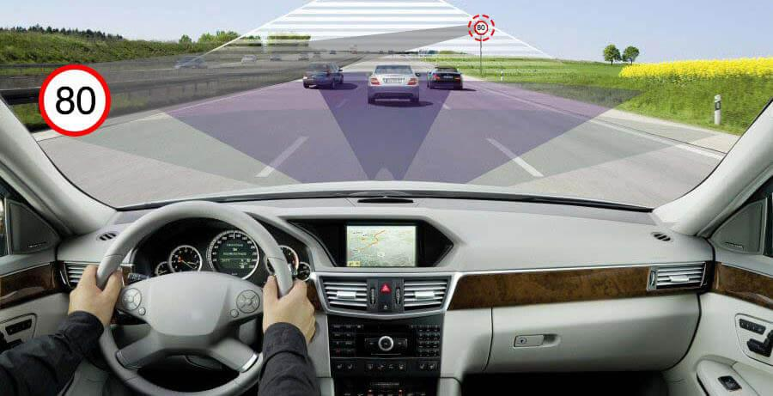

**TRAFFIC SIGN DETECTION & RECOGNITION PROGRESS REPORT**

**Developer’s Name: Kartik Jain, Mayank Vats, Mayank Sinha, Eraa**

**Report Date: November 28, 2020**

**Mentor: Pramod Shetty Sir**



**Progress:**

Our project consist of 3 phase:

* Detection Phase
* Recognition Phase
* Text to Speech conversion

Out of the 3 phase we have almost succeeded in the 2nd phase i.e. the recognition phase.

Our model run with the accuracy of 92.61% on Train dataset.

**Remaining Work:**

* The Detection Phase
* Text to Speech Conversion

We will soon be starting with these 2 phase of the projects.

**Difficulties Faced:**

It has been difficult for us to achieve the accuracy of 92% for the test set. We have tried

different algorithms such as ‘adam’, ‘SGD’ to achieve this accuracy.

But this accuracy is yet not enough to use it in real world, so we are trying further to achieve more

accuracy.